**Central African Republic country profile**

Published

1 August 2018

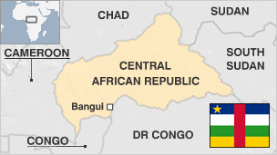

**The Central African Republic (CAR) has been unstable since its independence from France in 1960.**

It is rich in diamonds, gold, oil and uranium but has one of the world's poorest populations.

It was plunged into turmoil in 2013 when Muslim rebels from the Seleka umbrella group seized power in the majority Christian country. A band of mostly Christian militias, called the anti-balaka, rose up to counter the Seleka.

Seleka handed power to a transitional government in 2014 under international pressure but months of violence followed and the country was effectively partitioned, in spite of the presence of a UN peacekeeping force and a French mission.

The country is undergoing an internationally supervised transition involving a constitutional referendum as well as presidential and parliamentary elections.

* Read more [country profiles](http://news.bbc.co.uk/1/hi/country_profiles/) - Profiles by [BBC Monitoring](http://bbc.co.uk/monitoring)

**President: Faustin-Archange Touadera**

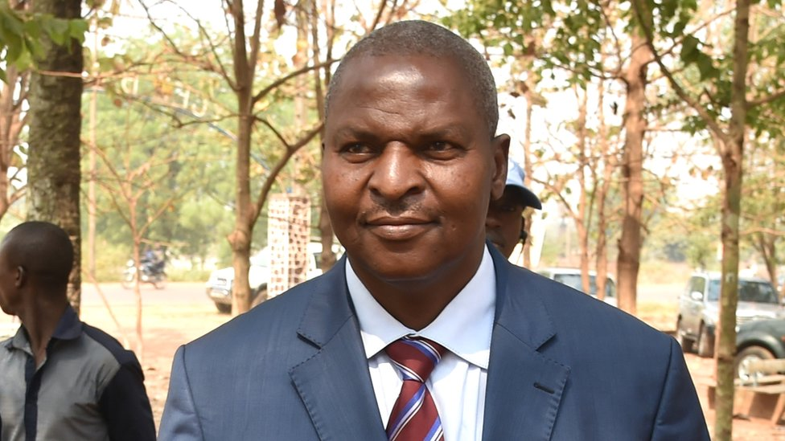image copyrightGetty Images

Faustin-Archange Touadera, a former prime minister and maths professor, was declared the winner of a presidential election in February 2016 seen as crucial to turning the page on years of sectarian violence.

Mr Touadera won 62.71% of the hotly contested run-off vote compared with 37.29 for Anicet-Georges Dologuele, who won the first round of the vote in December and conceded defeat in the second.

He campaigned as a peacemaker who could bridge the religious divide.

The well-respected former mathematics professor served as the last premier of ex-president Francois Bozize who was deposed in a coup in 2013.

The ouster of Bozize, a Christian, by the mostly Muslim Seleka rebels unleashed a spiral of violence between Muslim and Christian militias that left thousands dead, and many voters expressed a strong desire for peace when they cast their ballots.

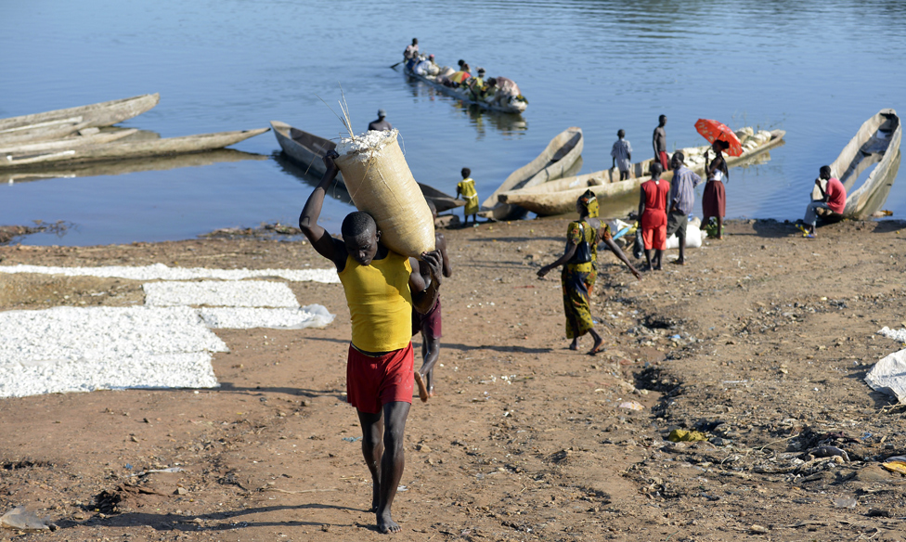image copyrightGetty Images

image captionThe Central African Republic has great agricultural potential as well as plentiful mineral resources, including diamonds

Radio is the most-popular medium. The media consist largely of low-circulation newspapers and "often-isolated" radio stations, says Reporters Without Borders (RSF).

Persistent conflict has hampered media development. Officials and armed groups have targeted journalists and media outlets.

# Central African Republic profile - Timeline

Published

1 August 2018

## A chronology of key events:

**1880s** - France annexes the area.

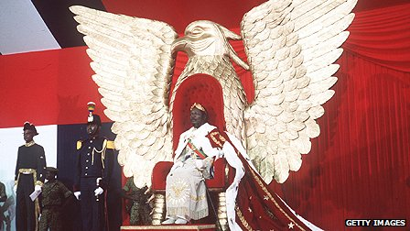image copyrightGetty Images

image captionJean-Bedel Bokassa had the reputation of one of Africa's most brutal post-independence leaders

**1894** - France sets up a dependency in the area called Ubangi-Chari and partitions it among commercial concessionaires.

**1910** - Ubangi-Chari becomes part of the Federation of French Equatorial Africa.

**1920-30** - Indigenous Africans stage violent protests against abuses by concessionaires.

**1946** - The territory is given its own assembly and representation in the French parliament; Barthelemy Boganda, founder of the pro-independence Social Evolution Movement of Black Africa (MESAN), becomes the first Central African to be elected to the French parliament.

**1957** - MESAN wins control of the territorial assembly; Boganda becomes president of the Grand Council of French Equatorial Africa.

## Independence

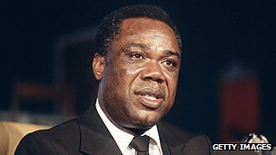image copyrightGetty Images

image captionDavid Dacko was the country's first president

**1958** - The territory achieves self-government within French Equatorial Africa with Boganda as prime minister.

**1959** - Boganda dies.

**1960** - The Central African Republic becomes independent with David Dacko, nephew of Boganda, as president.

**1962** - Dacko turns the Central African Republic into a one-party state with MESAN as the sole party.

**1964** - Dacko confirmed as president in elections in which he is the sole candidate.

## The Bokassa era

**1965** - Dacko ousted by the army commander, Jean-Bedel Bokassa, as the country faces bankruptcy and a threatened nationwide strike.

**1972** - Bokassa declares himself president for life.

**1976** - Bokassa proclaims himself emperor and renames the country the "Central African Empire".

**1979** - Bokassa ousted in a coup led by David Dacko and backed by French troops after widespread protests in which many school children were arrested and massacred while in detention.

**1981** - Dacko deposed in a coup led by the army commander, Andre Kolingba.

**1984** - Amnesty for all political party leaders declared.

**1986** - Bokassa returns to the CAR from exile in France.

**1988** - Bokassa sentenced to death for murder and embezzlement, but has his sentence commuted to life imprisonment.

## Ban on parties lifted

**1991** - Political parties permitted to form.

**1992** October - Multiparty presidential and parliamentary elections held in which Kolingba came in last place, but are annulled by the supreme court on the ground of widespread irregularities.

**1993** - Ange-Felix Patasse beats Kolingba and Dacko in elections to become president, ending 12 years of military rule. Kolingba releases several thousand political prisoners, including Bokassa, before standing down as president.

**1996** May - Soldiers stage a mutiny in the capital, Bangui, over unpaid wages.

**1997** November - Soldiers stage more mutinies.

**1997** - France begins withdrawing its forces from the republic; African peacekeepers replace French troops.

**1999** - Patasse re-elected; his nearest rival, former President Kolingba, wins 19% of the vote.

**2000** December - Civil servants stage general strike over back-pay; rally organised by opposition groups who accuse President Patasse of mismanagement and corruption deteriorates into riots.

## Coup bid

**2001** May - At least 59 killed in an abortive coup attempt by former president Andre Kolingba. President Patasse suppresses the attempt with help of Libyan and Chadian troops and Congolese rebels.

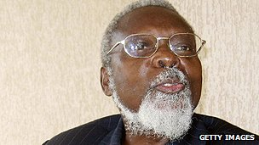image copyrightGetty Images

image captionPresident Ange-Felix Patasse was ousted by rebels

**2001** November - Clashes as troops try to arrest sacked army chief of staff General Francois Bozize, accused of involvement in May's coup attempt. Thousands flee fighting between government troops and Bozize's forces.

**2002** February - Former Defence Minister Jean-Jacques Demafouth appears in a Bangui court to answer charges related to the coup attempt of May 2001.

**2002** October - Libyan-backed forces help to subdue an attempt by forces loyal to dismissed army chief General Bozize to overthrow President Patasse.

## Patasse ousted

**2003** March - Rebel leader Francois Bozize seizes Bangui, declares himself president and dissolves parliament. President Ange-Felix Patasse is out of the country at the time. Within weeks a transitional government is set up.

**2004** December - New constitution approved in referendum.

**2005** May - Francois Bozize is named the winner of presidential elections after a run-off vote.

**2005** August - Flooding in the capital, Bangui, leaves up to 20,000 people homeless.

**2005** June onwards - Thousands flee lawlessness in north-west CAR for southern Chad. Aid bodies appeal for help to deal with the "forgotten emergency".

**2006** June - UN says 33 people have been killed in a rebel attack on an army camp in the north.

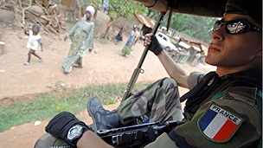image copyrightGetty Images

image captionFrance has troops in Central African Republic to protect its interests

**2006** August - Exiled Former President Ange-Felix Patasse is found guilty, in absentia, of fraud and sentenced to 20 years' hard labour.

**2006** October - Rebels seize Birao, a town in the north-east. President Bozize cuts short an overseas visit.

**2006** December - French fighter jets fire on rebel positions as part of support for government troops trying to regain control of areas in the northeast.

**2007** February - The rebel People's Democratic Front, led by Abdoulaye Miskine, signs a peace accord with President Bozize in Libya and urges fighters to lay down their arms.

**2007** May - The International Criminal Court says it is to probe war crimes allegedly committed in 2002 and 2003 following the failed coup against the Ange-Felix Patasse.

**2007** September - UN Security Council authorises a peacekeeping force to protect civilians from violence spilling over from Darfur in neighbouring Sudan.

**2008** January - Civil servants and teachers strike in protest over non-payment of salaries for several months.

Prime Minister Elie Dote and his cabinet resign a day before parliament was to debate a censure motion against him.

President Bozize appoints Faustin-Archange Touadera, an academic with no previous background in politics, to replace Mr Dote.

**2008** February - Ugandan Lord's Resistance Army rebels raid CAR.

## Peace process

**2008** June - Two of three main rebel groups - the Union of Democratic Forces for Unity (UFDR) and the Popular Army for the Restoration of Democracy (APRD) - sign peace agreement with government providing for disarmament and demobilisation of rebel fighters.

**2008** September - Parliament adopts amnesty law seen as last remaining obstacle to successful conclusion of peace talks between rebels and the government.

**2008** December - Government-rebel peace deal envisages formation of consensus government and elections in March 2010.

**2009** January - National unity government unveiled; includes leaders of the two main rebel groups. Main opposition UVNF criticises the changes to the cabinet as insufficient.

**2009** February - Ugandan LRA rebels cross into CAR.

**2009** March - French troops reportedly deploy in Bangui after rebels infiltrate the capital.

**2009** April - Clashes between government and rebels continue. UN Security Council agrees to creation of new UN peacebuilding office for CAR to address ongoing insecurity.

**2009** July - New electoral commission established after parliament approves new election law.

**2009** September - Ugandan army confirms that it is pursuing LRA rebels in CAR.

**2009** August - UN report says more than a million people have been affected by civil unrest in CAR.

**2009** October/November - Former President Ange-Felix Patasse returns from exile, hints that he may stand for the presidency in 2010.

**2010** February - Rights groups, opposition and France call for prove into claims - denied by the authorities - that rebel leader Charles Massi was tortured to death in government custody.

President Bozize says elections to be held on 25 April; opposition rejects date, fearing vote will be rigged.

**2010** April - Elections postponed. Parliament extends President Bozize's term until polls can be held.

**2010** May - UN Security Council votes to withdraw a UN force from Chad and the Central African Republic, deployed to protect displaced Chadians and refugees from Sudan's Darfur.

**2010** July - Rebels attack northern town of Birao.

**2010** September - Voter registration begins for presidential, parliamentary elections due in January 2011.

**2010** October - Four countries affected by LRA violence agree to form joint military force to pursue the rebels.

**2010** November - Ex-DR Congo vice-president Jean-Pierre Bemba goes on trial at International Criminal Court accused of letting his troops rape and kill in Central African Republic between 2002 and 2003.

**2010** December - 50th independence anniversary. Former self-styled Emperor Jean-Bedel Bokassa is officially rehabilitated.

**2011** January - Presidential and parliamentary elections. Mr Bozize wins another term.

**2011** April - Former President Ange-Felix Patasse dies aged 74.

**2011** December - The charity Medecins Sans Frontieres (MSF) warns that the Central country is in a state of chronic medical emergency because of epidemic diseases, conflict, an economic downturn and a poor health system.

**2012** March - African Union deploys a military force to hunt down Ugandan warlord Joseph Kony, believed to be in the Central African Republic.

**2012** August - Last historic armed group - Convention of Patriots for Justice and Peace (CPJP) - signs peace deal.

## Bozize ousted

**2012** November - New Seleka rebel coalition rapidly overruns north and centre of country.

**2013** March - Seleka rebels overrun the capital and seize power. President Bozize flees. Rebel leader Michel Djotodia suspends constitution and dissolves parliament in a coup condemned internationally.

**2013** August - Coup leader Michel Djotodia is sworn in as president.

UN Security Council warns CAR poses a risk to regional stability. UN chief Ban Ki-moon says CAR has suffered a "total breakdown of law and order".

**2013** September - Djotodia dissolves Seleka coalition. He is criticsed for failing to control the fighters.

**2013** October - UN Security Council approves the deployment of a UN peacekeeping force. It would support African Union troops already on the ground and French troops controlling the airport.

**2013** November - US casts doubt on Central African Republic official reports that Ugandan Lord's Resistance Army rebel leader Joseph Kony is among LRA figures negotiating their surrender with the CAR authorities.

**2013** December - With turmoil continuing in the country and rival Muslim and Christian fighters accused of killing hundreds of people, France steps up its deployment of troops to 1,600 in a bid to disarm the militias.

**2014** January - Interim president Michel Djotodia resigns over criticism that he failed to stop sectarian violence. Catherine Samba-Panza takes over as interim leader.

**2014** April - UN Security Council authorises a peacekeeping force of 12,000 troops.

**2014** May - French and Estonian troops take charge of security at the airport in Bangui under a European Union mandate from previous French force.

**2014** July - Muslim Seleka rebels and Christian "anti-balaka" vigilante forces agree to a tentative ceasefire at talks in Brazzaville.

**2014** August - Muslim politician Mahamat Kamoun tasked with leading a transitional government.

**2014** September - UN formally takes over and augments African Union peacekeeping mission, renamed Minusca. European Union's French mission remains in place.

**2015** January - The CAR government rejects a ceasefire deal made in Kenya between two militia groups aimed at ending more than a year of clashes, saying it was not involved in the talks.

UN accuses Christian militia of ethnic cleansing.

EU-commissioned research reveals how Seleka fighters were illegally supplied with guns made in China and Iran.

**2015** February - The UN says that surging violence in the Central African Republic has forced tens of thousands to flee their homes since the beginning of the year to escape killings, rape and pillaging by militias.

**2015** May - Prosecutors in France open a judicial investigation into alleged child abuse by French soldiers.

**2015** September - Communal clashes break out in Bangui after Muslim taxi-driver attacked.

**2015** November - Pope visits, calls for peace between Muslims, Christians.

**2015** December - New constitution approved in referendum. Parliamentary and presidential elections pass off peacefully, but constitutional court annuls results of parliamentary poll, citing irregularities.

**2016** February - Faustin-Archange Touadera wins presidential election in the run-off.

**2016** June - International Criminal Court sentences Congolese ex-rebel Jean-Pierre Bemba to eighteen years in prison for his militia's abuses in CAR between 2002 and 2003.

**2016** July - Kidnappings by Lords Resistance Army reportedly on increase in CAR.

**2017** April - Uganda withdraws its forces from the Central African Republic where it has been fighting the Lord's Resistance Army for five years.

**2017** May - Upsurge in violence, blamed in part on the withdrawal of foreign forces.

Several UN peacekeepers are killed in a number of attacks, including on a base and a convoy.

**2017** July - Several aid agencies withdraw because of the violence, saying they are leaving tens of thousands without support.

**2017** September - The UN refugee agency says continuing violence has caused the highest level of displacement since the start of the crisis in 2013. More than 1 million people have left their homes.

**2017** November - UN Security Council extends mandate of the peacekeeping mission MINUSCA for another year and increases its size to some 13,000 troops and police.

**2018** January - The International Committee of the Red Cross warns that the situation in the country is getting worse, with half of the population in need of humanitarian aid.

**2018** June - International Criminal Court overturns conviction of Congolese ex-rebel Jean-Pierre Bemba for war crimes committed in CAR.

**2018** July - Three Russian journalists killed, reportedly while working on a documentary about Wagner, a Kremlin-linked mercenary company believed to be active in CAR.